# Procedure

## Definition:

In Oracle PL/SQL, a PROCEDURE is a named PL/SQL subprogram which can (optionally) accept parameters and may or may not return a value to the host. Its major function is to embed a business logic process and perform data manipulation with the help of the supplied data.

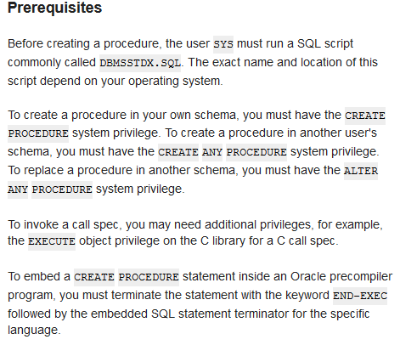

## Create procedure

<https://docs.oracle.com/cd/B19306_01/server.102/b14200/statements_6009.htm>

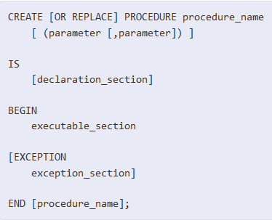

以上。

### Use cursors in stored procedures

Create or replace procedure procedure_cur

As

varempno emp.empno%type;

vardeptno emp.deptno%type;

vardept dept%rowtype;

Cursor curdept is select * from dept;

Begin

Open curdept;

Loop

Fetch curdept into vardeptno;

Exit when curdept%notfound;

Select emp.deptno into vardeptno from emp;

If sql%found then

Dbms_output.put_line(‘-------------’);

Dbms_output.put_line(vardeptno||’:’);

End if;

For vardept in

(

Select * from deptno where

)

### Use DDL in stored procedure

EXECUTE IMMEDIATE definition:

The EXECUTE IMMEDIATE statement executes a dynamic SQL statement or anonymous(匿名) PL/SQL block. You can use it to issue SQL statements that cannot be represented(代表) directly(直接的) in PL/SQL, or to build up(加强) statements where you do not know all the table names, WHERE clauses, and so on in advance(预先).

Execute immediate ‘insert into table(column1,column2,....) values(column1,column2,....)’

## Procedure with parameter

In,out,inout 参数定义：

